# 2019 DDJ-1000 v6.6.0 - BOME mapping for Traktor Pro 3 and 2 with jog Screens - DJ Estrela

**TO DOWNLOAD:** you can ONLY download if you register and then verify your email in the DJTT site!

FEATURE LIST:

* Jog Screens
* 7x Jogwheel FX chains
* 5x MixerFX
* 11x MacroFX
* 21x padFX (“instant gratification”)
* 3x tone play modes (“keyboard mode”)
* 8x Rolls
* Slicer
* Dedicated preview player
* Manual adjust of Loops (via jogs)
* Beatjump and Loops pages
* Reverse Flux / Vinyl Stop
* End of track warning blinks / other CDJ emulation features
* All functions reachable without shifts

LINKS:

* Download Link: [https://maps.djtechtools.com/mappings/9279](https://maps.djtechtools.com/mappings/9278)
* Documentation: [https://github.com/pestrela/music_scripts/blob/master/traktor/ddj_1000_traktor_mapping](https://github.com/pestrela/music_scripts/blob/master/traktor/ddj_1000_traktor_mapping/)
* Video demo: <https://youtu.be/h9tQZEHr8hk>

DOCUMENTATION IN THE ZIP FILE:

* Quick overview
* Installation guide
* FAQ
* User manual
* Demo Videos

COMPATIBILITY:

* Traktor**:** This mapping works perfectly in both Traktor Pro 3 and Traktor Pro 2.
* DDJ-1000**:** As good as it gets. This is where the mapping was developed.
* DDJ-800:Pretty good coverage, but not perfect. The zip file contains a specific TSI for the DDJ-800.
* DDJ-1000SRT: see <https://maps.djtechtools.com/mappings/9222>

ABOUT THIS MAPPING:

* This is the only mapping for the DDJ-1000 that supports Jog Screens. It works on both Traktor 3 and 2. It requires the 3rd-party BOME Pro MIDI translator. Free trial versions are available to test everything.
* It is also the most complete by far. It supports TP3 MixerFX, MacroFX, JogFX chains, padFX, Keyboard mode, Rolls, and a Preview Player. Latest features are CDJ-emulation, Loops adjust and Beatjump shortcuts.
* All pad modes are reachable with only two clicks without any shifts. Pressing the “mode” button will conveniently cycle the top-2 pages of that mode.
* Issues? First, read the extensive documentation; then do not hesitate reporting ANY problems. Do NOT just press thumbs down without any steps to reproduce your issue. Thank you.
* All my mappings are a free gift to the community, to enable DJs to use their preferred Software with their preferred. If you want further appreciation, PayPal donations are welcome ([pedro.estrela@gmail.com](mailto:pedro.estrela@gmail.com))

v6.5.0 DEMO Jog Screens using BOME: <https://youtu.be/h9tQZEHr8hk>

* 0:35 Needle position, BPM, Tempo percentage, Time elapsed/Remain, Key Variation
* 1:45 Loop/Beatjump sizes are displayed on the main display
* 2:25 Shift layers shows Base BPM, Tempo range, Loop sizes and Beatjump Sizes
* 4:00 Scratching quality was improved; shift+vinyl disables scratching
* 4:47 shift+quantize resets the jog screens
* 6:04 Quick demo of the previous features: JogFX, Rolls, PadFx, MixerFX, MacroFx
* 8:08 Pioneer BeatFX are in MST channel; TK effects are in channel 1..4

v6.3.3 Update description: <https://www.youtube.com/watch?v=2QKGQ_JUNXo>

* 0:15 JogRing now shows the active deck; Blinks in jogfx mode
* 1:25 Backspins are now possible
* 1:35 Sync is now "toggle"
* 1:50 Fixes to cue monitor
* 3:00 Putting the screens to work
* 3:50 Files on the archive (including installation help)
* 4:50 USER REQUEST: traktor effects list suggestions

v6.3.0 Features / Demo: <https://www.youtube.com/watch?v=EkSJ9Ug9Zuk>

* 0:30 5-minute overview of the most important features (Jogfx, MixerFx, Loops, Shift2, PreviewPlayer, ...)
* 5:50 The most-used pad modes are now accessible without any shifts (padFX, MacroFx, JogFX). Pressing "mode" twice cycles 2x top pages; pressing "left" cycles all 4x pages
* 8:40 Only the secondary pad modes now requires shift (keyboard, slicer, remix decks)
* 9:15 Memory button = second shift button
* 10:10 Vinyl long stop / vinyl break
* 10:30 Browser: preview player / browser / waveform zoom
* 11:50 Loops / BeatJump
* 15:00 How to correct loops by +1 beat
* 15:40 Beatgrid slide / adjust / lock analysis
* 17:30 TP3 mixer FX: flanger / time gater / crush / noise
* 18:41 How to change mixerfx list in preferences
* 19:30 MacroFX page1: wormhole, polarwind, flighttest, laserslicer
* 20:30 BeatFX shortcuts: T3 delay / flanger / reverb
* 20:51 MacroFX page2 (seven more macroFX)
* 21:20 Manual FX (non-automated). Use MST for pioneer effects!
* 23:00 Mobius FXs (=forever rising)
* 23:50 CAUTION: beware that USB selector does NOT stop USB mixer
* 24:35 JogFX in detail (combo of 3x FX on the jogwheels)
* 26:40 MacroFX in detail
* 27:20 PadFX in detail: quantized roll / Non-quantize roll / 3x padFX pages
* 29:30 Keyboard mode
* 30:30 Slicer mode
* 31:30 Slip reverse / reverse
* 31:40 2-deck and 4-deck automatic layout

Installation Instructions:

* Please use the big "import" button on the lower left corner of the settings
* VERY IMPORTANT: YOU NEED TO IMPORT THE TSI TWICE FOR THE FX LIST TO BE CORRECT! (this is a traktor bug)
* Tutorial on how to import midi mappings in Traktor: <https://www.youtube.com/watch?v=6Jw8VyzPrlQ&t=2s>

Other:

* The “support folder” now includes the old official Pioneer installation PDF for the DDJ-SX2. The manual installation steps are the same for the DDJ-1000.
* Images: <https://www.facebook.com/pedro.vale.estrela/media_set?set=a.2244380098947850>
* Technical discussion: <http://forum.djtechtools.com/showthread.php?t=96024>

Function Overview:

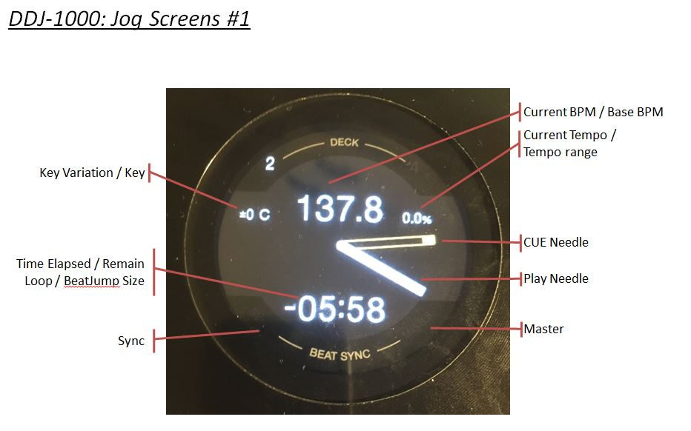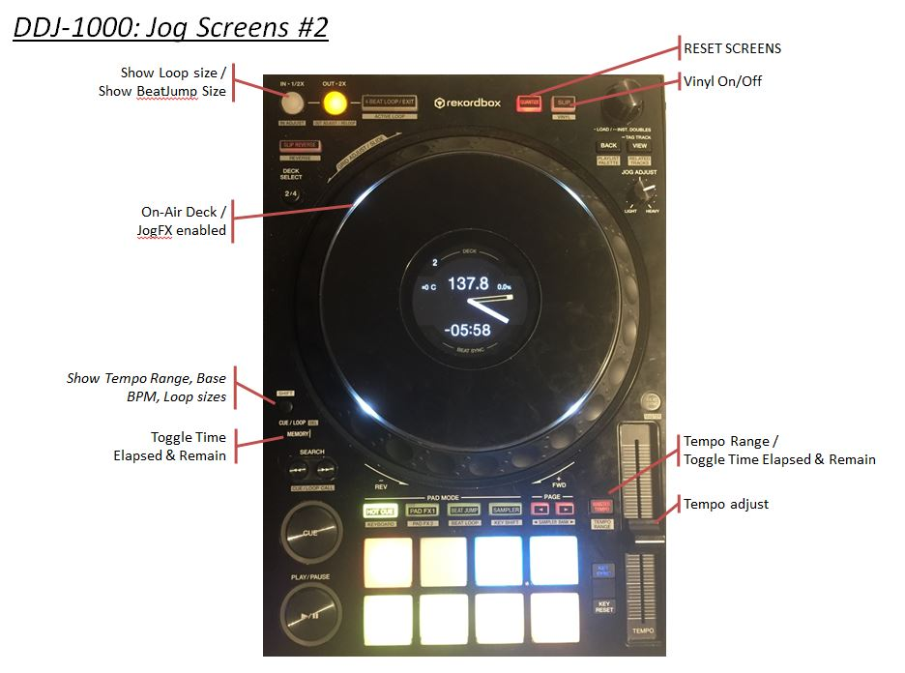

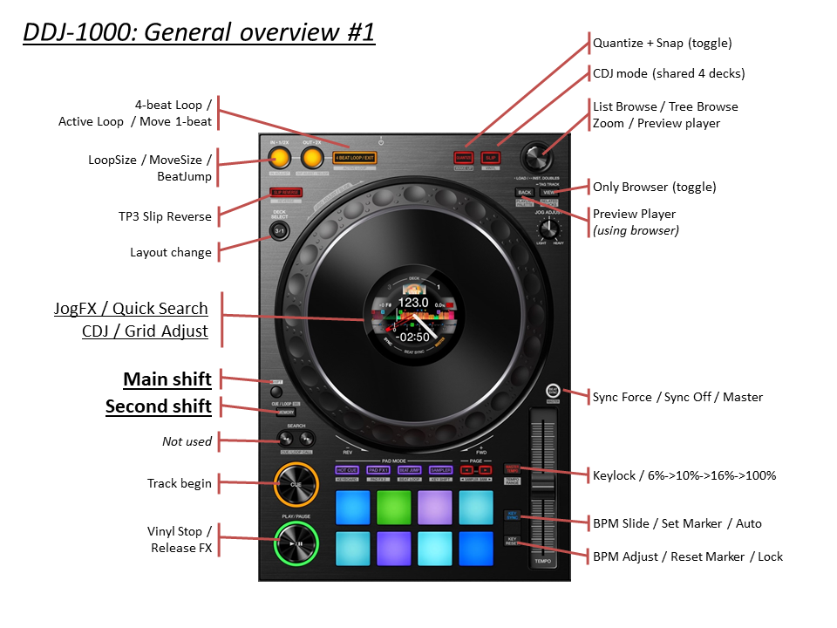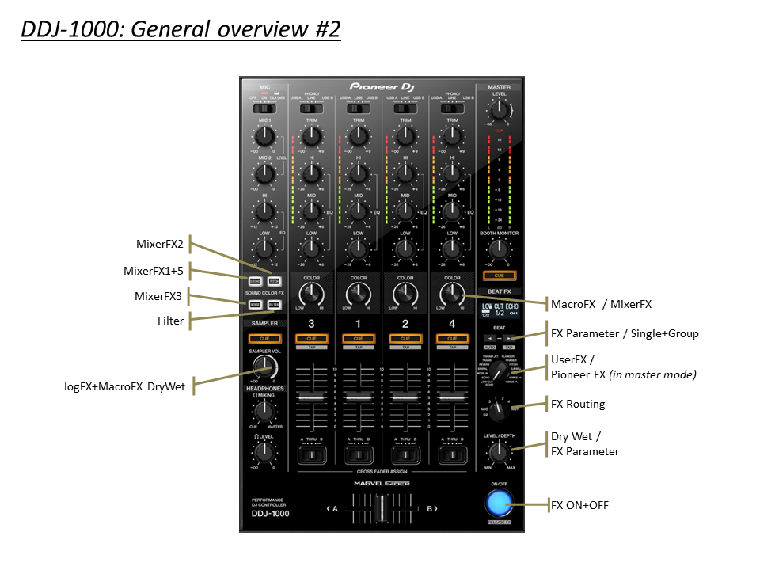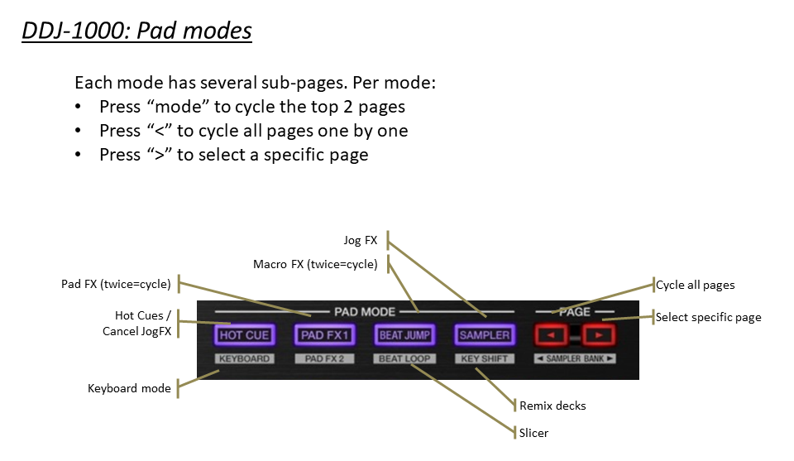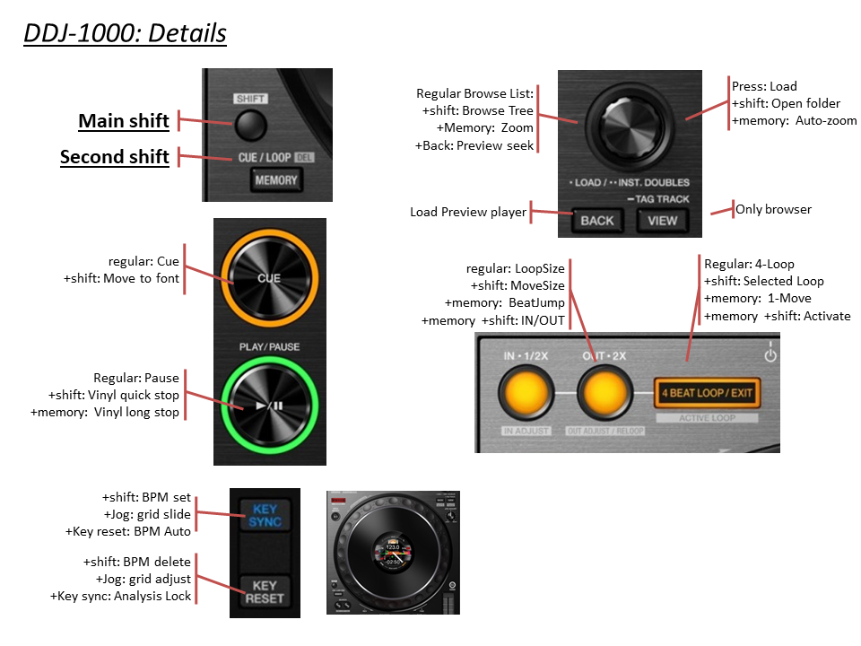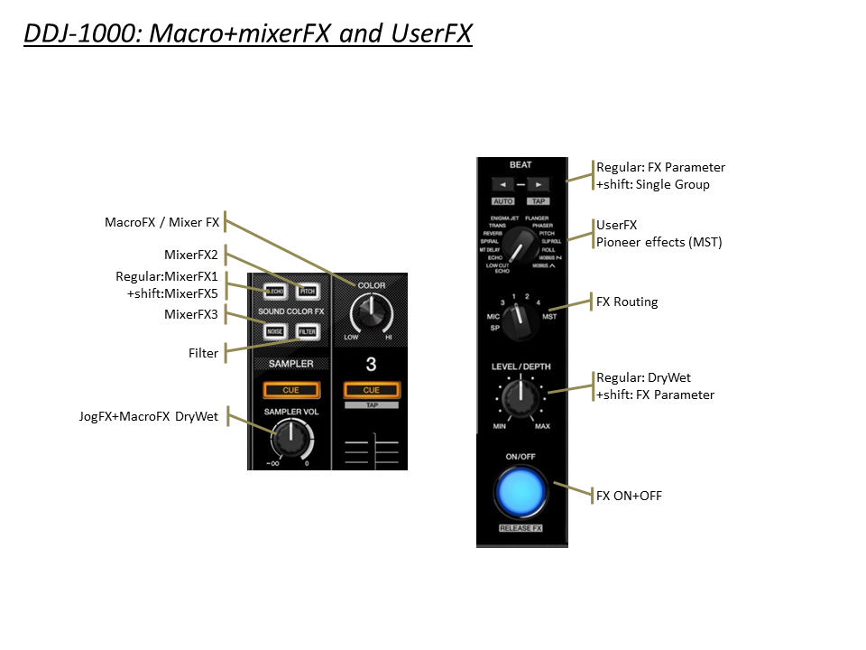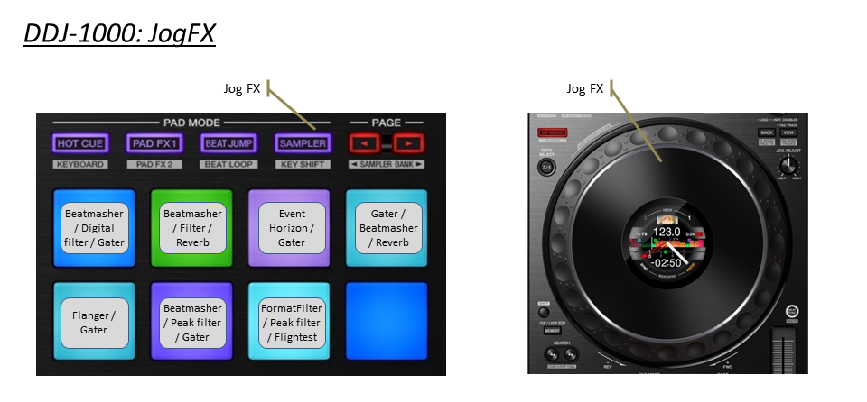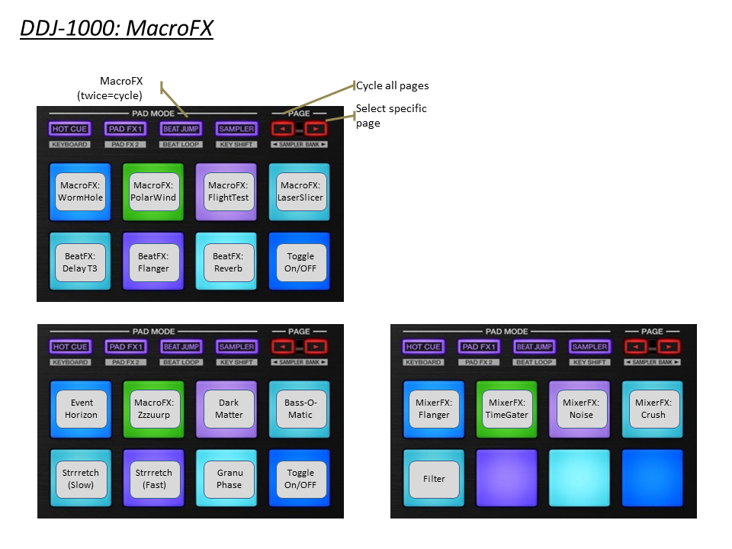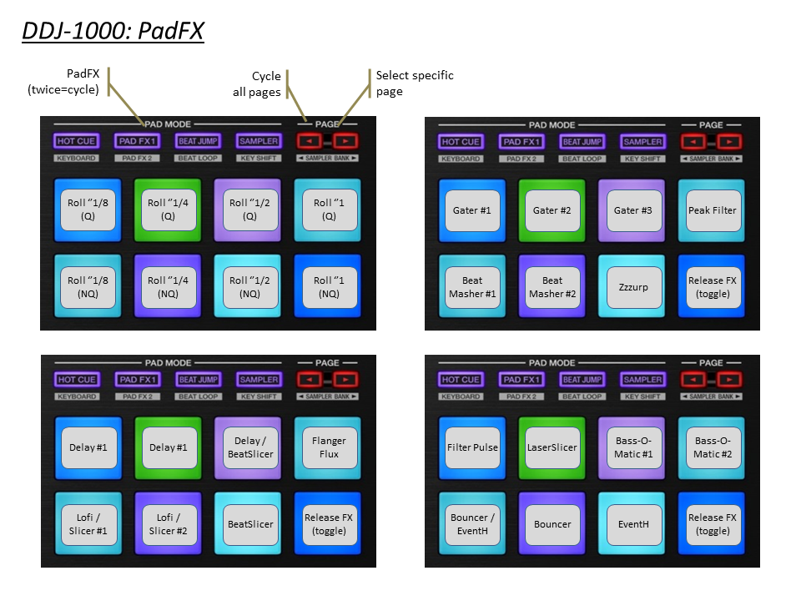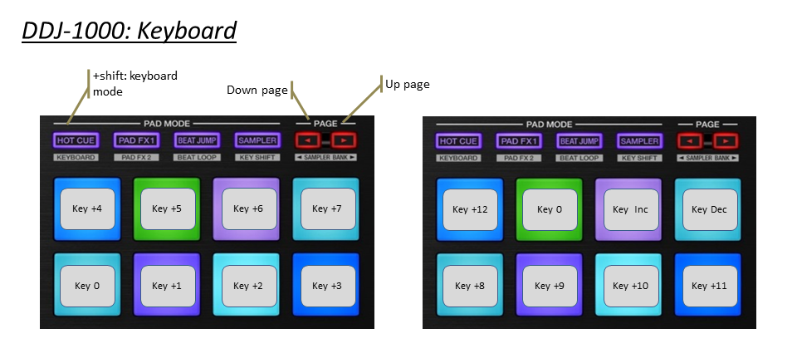

Complete reference:

|  |  |  |  |  |
| --- | --- | --- | --- | --- |
|  |  |  |  |  |
|  |  | Section JOG DISPLAYS |  |  |
|  | DDJ-1000 | Main Function | +Shift | +Memory Shift |
|  | BUTTON: LOOPS | Show Loop / Move size (for 2s) | *Move size* | *BeatJump* |
|  | BUTTON: MASTER TEMPO | *KeyLock Toggle* | *Tempo Range (6/10/16/100)* | Toggle Elapsed/Remain |
|  | BUTTON: QUANTIZE |  | RESET SCREENS |  |
|  | BUTTON: SLIP |  | Vinyl On/Off |  |
|  |  |  |  |  |
|  | DISPLAY: TIME | Time Elapsed / Remain | Loop Size / Move size |  |
|  | DISPLAY: BPM | Current BPM | Original BPM |  |
|  | DISPLAY: NEEDLE | Current Position |  |  |
|  | DISPLAY: PERCENTAGE | BPM Percentage | Tempo Range |  |
|  |  |  |  |  |
|  | DISPLAY: KEY VALUE | *Not Available yet* |  |  |
|  | DISPLAY: KEY VARIATION | Key Variation |  |  |
|  |  |  |  |  |
|  | JOG RING LED | On-Air Deck / JogFX enabled |  |  |
|  | DISPLAY: SYNC | Sync |  |  |
|  | DISPLAY: MASTER | Master |  |  |
|  |  |  |  |  |
|  |  |  |  |  |
|  |  |  |  |  |
|  |  | Section DECK |  |  |
|  | DDJ-1000 | Main Function | +Shift | +Memory Shift |
|  | SHIFT | Main Shift |  |  |
|  | MEMORY | 2nd Shift |  |  |
|  | KEY SYNC | *(see grid section)* | *(see grid section)* |  |
|  | KEY RESET | *(see grid section)* | *(see grid section)* |  |
|  |  |  |  |  |
|  | JOG (platter ) | Scratch / Pitch Bend | Quick Search |  |
|  | JOG (wheel side) | Pitch Bend |  |  |
|  |  |  |  |  |
|  | MASTER TEMPO | KeyLock Toggle | Tempo Range (6/10/16/100) | Time Elapsed / Remain |
|  | SLIP REVERSE | TP3 Reverse Flux | TP3 Reverse |  |
|  | DECK SELECT (1/2/3/4) | Select Deck 1-4 | Deck Flavor |  |
|  | SEARCH << >> |  |  |  |
|  |  |  |  |  |
|  | PLAY | Play/Pause | Vinyl Stop |  |
|  | CUE | Cue | Track Begin |  |
|  | BEAT SYNC | Sync Toggle | Sync Off | Set as tempo Master |
|  |  |  |  |  |
|  | QUANTIZE / WAKE UP | Quantize + Snap Toggle | Reset mapping |  |
|  | SLIP / VINYL | Flux Mode On/Off | Scratch On/Off |  |
|  | TEMPO | Tempo Control | Tempo Control (No sync) |  |
|  |  |  |  |  |
|  |  |  |  |  |
|  |  | Section BROWSER |  |  |
|  | DDJ-1000 | Main Function | +Shift | +Memory Shift |
|  | Turn Browser Knob | Scroll List | Scroll Tree | WaveForm Zoom Adjust |
|  | Push Browser Knob | Load Track | Open / close Folder | WaveForm Zoom Auto |
|  | BACK | Preview Player (Hold) | Scroll Favorites |  |
|  | VIEW | Browser Only (Toggle) | Goto Collection |  |
|  |  |  |  |  |
|  |  |  |  |  |
|  |  |  |  |  |
|  |  | Section BEATGRID |  |  |
|  | DDJ-1000 | + KEY SYNC | + KEY RESET | +Shift |
|  | KEY SYNC |  |  | Set Grid Marker |
|  | KEY RESET |  |  | Delete Grid Marker |
|  | KEY SYNC+RESET | Track ON/OFF LOCK | Auto Grid Marker |  |
|  |  |  |  |  |
|  | Turn Jog Wheel | Move Grid | BPM +/- |  |
|  | Turn BROWSER | Move Grid [ FINE ] | BPM +/- [ FINE ] |  |
|  | Push BROWSER | SLIDE AUTO | BPM AUTO |  |
|  |  |  |  |  |
|  |  |  |  |  |
|  |  | Section LOOP |  |  |
|  | DDJ-1000 | Main Function | +Shift | +Memory Shift |
|  | AUTO LOOP | 4-Beat loop | Loop (selected size) | Select Move 1-beat |
|  | 1/2X | Select Loop 1/2X | Select Move 1/2X | BeatJump / LoopMove |
|  | 2X | Select Loop 2X | Select Move 2X | BeatJump / LoopMove |
|  | IN | Loop IN | CaptureLoop (remix deck) |  |
|  | OUT | Loop OUT | DeleteLoop (remix deck) |  |
|  |  |  |  |  |

|  |  |  |  |
| --- | --- | --- | --- |
|  |  |  |  |
|  |  | Section MIXER |  |
|  | DDJ-1000 | Main Function | +Shift |
|  | MASTER LEVEL | Volume Master Out |  |
|  | MASTER CUE | MASTER CUE |  |
|  | BOOTH LEVEL | Volume Booth Out |  |
|  | TRIM | Gain |  |
|  | HI | Hi |  |
|  | MID | Mid |  |
|  | LOW | Low |  |
|  | CUE MONITORING | Monitoring | Echo Out Type (1/2/3/4) |
|  | CH FADER | Channel Fader | CH Fader Start |
|  | CROSSFADER | Crossfader |  |
|  | INPUT SELECT | Input select |  |
|  | CROSS F. CURVE | Crossfader Curve |  |
|  | USB A & B | USB A & B | Unload Deck |
|  |  |  |  |
|  |  |  |  |
|  |  |  |  |
|  |  |  |  |
|  |  | section BEAT FX |  |
|  | DDJ-1000 | Main Function | +Shift |
|  | BEAT < | Parameter #3 left |  |
|  | BEAT > | Parameter #3 Right |  |
|  | SELECT 1/2/3/4 | Select FX4 |  |
|  | Use MST for Pioneer FX |
|  | LEVEL/DEPTH | Dry/Wet FX4 | Vinyl Break (Release FX) |
|  |  |  |  |
|  | LOW CUT | Delay T3 |  |
|  | ECHO | Delay |  |
|  | MT DELAY | Ramp Delay |  |
|  | SPIRAL | Auto Bouncer |  |
|  | REVERB | Reverb T3 |  |
|  | TRANS | Gater |  |
|  | ENIGMA JET |  |  |
|  | FLANGER | Flanger |  |
|  | PHASER | Phaser |  |
|  | PITCH | Reverse Grain |  |
|  | SLIP ROLL | BeatSlicer |  |
|  | ROLL | BeatMasher 2 |  |
|  | MOBIUS SAW |  |  |
|  | MOBIUS TRI |  |  |
|  |  |  |  |
|  |  |  |  |
|  |  | section HOTCUE |  |
|  | DDJ-1000 | Main Function | +Shift |
|  | PAD 1 | Hotcue 1 | Delete Hotcue |
|  | PAD 2 | Hotcue 2 | Delete Hotcue |
|  | PAD 3 | Hotcue 3 | Delete Hotcue |
|  | PAD 4 | Hotcue 4 | Delete Hotcue |
|  | PAD 5 | Hotcue 5 | Delete Hotcue |
|  | PAD 6 | Hotcue 6 | Delete Hotcue |
|  | PAD 7 | Hotcue 7 | Delete Hotcue |
|  | PAD 8 | Hotcue 8 | Delete Hotcue |
|  | HOTCUE [Long Press] | Quantize |  |
|  | PARAMETER < |  | PITCH -0,01 |
|  | PARAMETER > |  | PITCH +0,01 |
|  |  |  |  |
|  |  |  |  |
|  |  |  |  |
|  |  | section BEATLOOP |  |
|  | = SLICER |
|  | DDJ-1000 | Main Function | +Shift |
|  | PAD 1 | Slicer #1 | 8 beats |
|  | PAD 2 | Slicer #2 | 16 beats odd |
|  | PAD 3 | Slicer #3 | 16 beats even |
|  | PAD 4 | Slicer #4 |  |
|  | PAD 5 | Slicer #5 |  |
|  | PAD 6 | Slicer #6 |  |
|  | PAD 7 | Slicer #7 |  |
|  | PAD 8 | Slicer #8 |  |
|  | PARAMETER < |  |  |
|  | PARAMETER > |  |  |
|  |  |  |  |
|  |  |  |  |
|  |  | section KEY SHIFT |  |
|  | = SAMPLER |
|  | DDJ-1000 | Main Function | +Shift |
|  | PAD 1 | Cell #1 / #9 | Column #1 Mute |
|  | PAD 2 | Cell #2 / #10 | Column #2 Mute |
|  | PAD 3 | Cell #3 / #11 | Column #3 Mute |
|  | PAD 4 | Cell #4 / #12 | Column #4 Mute |
|  | PAD 5 | Cell #5 / #13 | Column #1 Loop / 1-shot |
|  | PAD 6 | Cell #6 / #14 | Column #2 Loop / 1-shot |
|  | PAD 7 | Cell #7 / #15 | Column #3 Loop / 1-shot |
|  | PAD 8 | Cell #8 / #16 | Column #4 Loop / 1-shot |
|  | PARAMETER < | Pad 1 to 8 | Page - |
|  | PARAMETER > | Pad 9 to 16 | Page + |
|  |  |  |  |
|  |  |  |  |
|  |  | section KEYBOARD |  |
|  | DDJ-1000 | Main Function | +Shift |
|  | PAD 1 | Key +4 | Key +12 |
|  | PAD 2 | Key +5 | Key 0 |
|  | PAD 3 | Key +6 | Key Inc |
|  | PAD 4 | Key +7 | Key Dec |
|  | PAD 5 | Key 0 | Key +8 |
|  | PAD 6 | Key +1 | Key +9 |
|  | PAD 7 | Key +2 | Key +10 |
|  | PAD 8 | Key +3 | Key +11 |
|  |  |  |  |
|  | PARAMETER < | Next PFX page |  |
|  | PARAMETER > | Choose PFX pages |  |
|  |  |  |  |
|  |  |  |  |
|  |  |  |  |
|  |  | section SAVED LOOP |  |
|  | = PAD FX |
|  | DDJ-1000 | Main Function | +Shift |
|  | PAD 1 | Gater #1 | PAD FX page 1 |
|  | PAD 2 | Gater #2 | PAD FX page 2 |
|  | PAD 3 | Gater #3 | PAD FX page 3 |
|  | PAD 4 | Peak Filter | ROLL |
|  | PAD 5 | Beatmasher #1 |  |
|  | PAD 6 | Beatmasher #2 |  |
|  | PAD 7 | Zzzurp |  |
|  | PAD 8 | Release FX (toggle) |  |
|  |  |  |  |
|  | PAD 1 | Delay #1 | PAD FX page 1 |
|  | PAD 2 | Delay #2 | PAD FX page 2 |
|  | PAD 3 | Delay / BeatSlicer | PAD FX page 3 |
|  | PAD 4 | Flanger Flux | ROLL |
|  | PAD 5 | DigitalLofi / BeatSlicer #1 |  |
|  | PAD 6 | DigitalLofi / BeatSlicer #2 |  |
|  | PAD 7 | BeatSlicer |  |
|  | PAD 8 | Release FX (toggle) |  |
|  |  |  |  |
|  | PAD 1 | Filter Pulse | PAD FX page 1 |
|  | PAD 2 | LaserSlicer | PAD FX page 2 |
|  | PAD 3 | Bass-O-Matic #1 | PAD FX page 3 |
|  | PAD 4 | Bass-O-Matic #2 | ROLL |
|  | PAD 5 | Bouncer / EventHorizon |  |
|  | PAD 6 | Bouncer |  |
|  | PAD 7 | EventHorizon |  |
|  | PAD 8 | Release FX (toggle) |  |
|  |  |  |  |
|  | PAD 1 | Roll ‘’1/8 (quantize) | PAD FX page 1 |
|  | PAD 2 | Roll ‘’1/4 (quantize) | PAD FX page 2 |
|  | PAD 3 | Roll ‘’1/2 (quantize) | PAD FX page 3 |
|  | PAD 4 | Roll ‘’1 (quantize) | ROLL |
|  | PAD 5 | Roll ‘’1/8 (non-quantize) |  |
|  | PAD 6 | Roll ‘’1/4 (non-quantize) |  |
|  | PAD 7 | Roll ‘’1/2 (non-quantize) |  |
|  | PAD 8 | Roll ‘’1 (non-quantize) |  |
|  |  |  |  |
|  | PARAMETER < | Next PFX page |  |
|  | PARAMETER > | Choose PFX pages |  |
|  |  |  |  |
|  |  |  |  |
|  |  |  |  |
|  |  | section COLOR FX |  |
|  | = MIXER FX |
|  | DDJ-1000 | Main Function | +Shift |
|  | DUB ECHO | MixerFX: Flanger | MixerFX: Noise |
|  | PITCH | MixerFX: TimeGater |  |
|  | NOISE | MixerFX: Crush |  |
|  | FILTER | Filter |  |
|  |  |  |  |
|  | FILTER (KNOB) | Macro FX / Mixer FX |  |
|  | SAMPLER VOLUME | Macro FX Wet |  |
|  |  |  |  |
|  |  |  |  |
|  |  |  |  |
|  |  | section BEAT JUMP |  |
|  | = MACRO FX / MIXER FX |
|  | DDJ-1000 | Main Function | +Shift |
|  | PAD 1 | MacroFX: WormWhole | MACRO FX page 1 |
|  | PAD 2 | MacroFX: PolarWind | MIXER FX |
|  | PAD 3 | MacroFX: FlightTest | MACRO FX page 2 |
|  | PAD 4 | MacroFX: LaserSlicer |  |
|  | PAD 5 | BeatFX: Delay T3 |  |
|  | PAD 6 | BeatFX: Flanger |  |
|  | PAD 7 | BeatFX: Reverb |  |
|  | PAD 8 | Toggle On/OFF |  |
|  |  |  |  |
|  | PAD 1 | MixerFX: Flanger | MACRO FX page 1 |
|  | PAD 2 | MixerFX: TimeGater | MIXER FX |
|  | PAD 3 | MixerFX: Noise | MACRO FX page 2 |
|  | PAD 4 | MixerFX: Crush |  |
|  | PAD 5 | Filter |  |
|  | PAD 6 |  |  |
|  | PAD 7 |  |  |
|  | PAD 8 | Toggle On/OFF |  |
|  |  |  |  |
|  | PAD 1 | MacroFX: EventHorizon | MACRO FX page 1 |
|  | PAD 2 | MacroFX: Zzzuurp | MIXER FX |
|  | PAD 3 | MacroFX: DarkMatter | MACRO FX page 2 |
|  | PAD 4 | MacroFX: Bass-O-Matic |  |
|  | PAD 5 | MacroFX: Strrretch (Slow) |  |
|  | PAD 6 | MacroFX: Strrretch (Fast) |  |
|  | PAD 7 | MacroFX: GranuPhase |  |
|  | PAD 8 | Toggle On/OFF |  |
|  | PARAMETER < | Next MFX page |  |
|  | PARAMETER > | Choose MFX pages |  |
|  |  |  |  |
|  |  |  |  |
|  |  |  |  |
|  |  | section SLICER LOOP |  |
|  | = JOG FX |
|  | DDJ-1000 | Main Function | +Shift |
|  | PAD 1 | Beatmasher / Digital filter / Gater |  |
|  | PAD 2 | Beatmasher / Filter / Reverb |  |
|  | PAD 3 | Eventhorizon / Gater |  |
|  | PAD 4 | Gater / Beatmasher / Reverb |  |
|  | PAD 5 | Flanger / Gater |  |
|  | PAD 6 | Beatmasher / Peak filter / Gater |  |
|  | PAD 7 | FormatFilter / Peak filter / Flightest |  |
|  | PAD 8 | Release FX (toggle) |  |
|  | PARAMETER < |  |  |
|  | PARAMETER > |  |  |
|  |  |  |  |